**inSight 2017**

**Department : Department of Training and placements**

**Problem Title : Dynamic form for feedback.**

**Problem Code : PS07**

**Problem Description :**

Many Training programs like soft skills, aptitude, company specific trainings are given by the placement departments. In order to improve the quality of these training programs feedback plays a key role. An application should be developed in order to atomize the feedback process. The application should provide option to generate a dynamic form which would help take the feedback specific to the training and should also be able to generate a report whenever required.

**Proposed solution:**

We’ll be developing a web application to intake the feedback from the participants. Participants will have to scan the QR code to fill the feedback form. The form will contain different sections like, was the event INTERACTIVE, WELL MANAGED etc. the individual will have to rate the sections from 0 to 5, 0 being the least and 5 being the highest. Later these data will be updated into the database (ratings given by each individual). Average of all the sections will be considered to generate the report in the form of charts.

**Technology Stack :**

SQL, DHTML, QR CODE GENERATER, CSS

**Use Case:***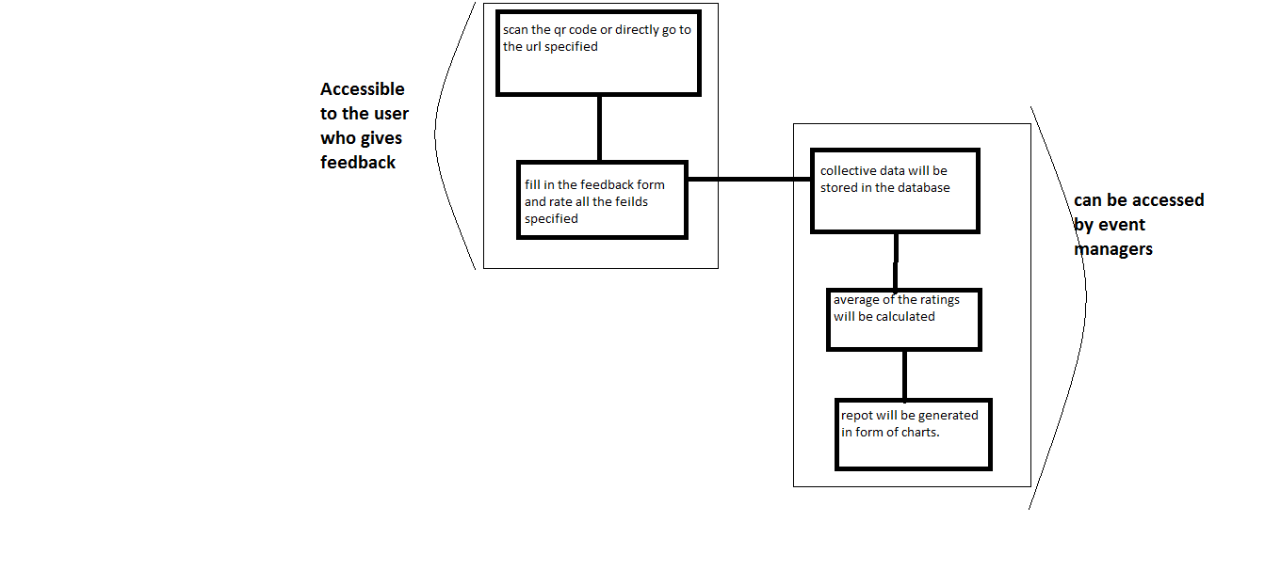*

Participants are asked to scan the QR code / directly visit the webpage. A feedback form with different sections will be displayed. Participants will have to rate those sections. All these ratings will be stored in the local server database. Average of each sections will be calculated and later a report will be created in the form of charts.

**Team Members details:**

|  |  |  |  |  |
| --- | --- | --- | --- | --- |
| **Role** | **Name** | **USN** | **Email id** | **Phone no.** |
| Team Leader | Kumar shubham | 1SI16IS026 | [Just.chill.sit@gmail.com](mailto:Just.chill.sit@gmail.com) | 7545962949 |
| Team Member 1 | Annapoorneshwari k. | 1SI16TE003 | [anukrishnakanth98@gmail.com](mailto:anukrishnakanth98@gmail.com) | 7259207629 |
| Team Member 2 | Udhav mohata | 1SI16TE045 | [udhavmohata1@gmail.com](mailto:udhavmohata1@gmail.com) | 9543132564 |